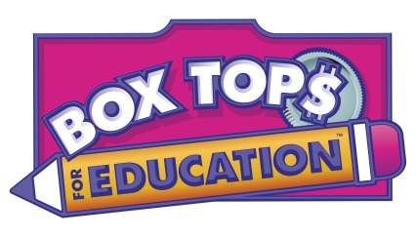
SCA Collects
Box Tops SPECIAL
Box Top Earnings
Decline in Amount Earned
Collecting Box Tops for our school is one free way to help us! It costs you nothing and our school earns money! Don’t throw away those $0.10 Box Tops in the trash. Collect them and send them in with your child. If you have children in both the Primary and Elementary School, consider sharing the Box Tops for both schools. Ask family members to help collect.
2012 – 2013 $3,123.60
2013 – 2014 $2,862.90
2014 – 2015 $2,421.20
2015 – 2016 $1,506.30
*Earnings go toward things PE equipment, book sets for classroom, music equipment, SOL Snacks, etc.
CLASSROOM REWARDS
*Class that turns in the most earns a Pizza/Karaoke Party!
3000 Box Tops = Ice Cream Party
2000 Box Tops= Popcorn Party
1000 Box Tops = Dance & Cookies
500 Box Tops = Game Time
Goodbye to Campbell’s Labels
This is the last year to clip and turn in Campbell’s Labels for Education. Beginning August 1st, only items with the Labels for Education logo and barcode will be accepted as points.

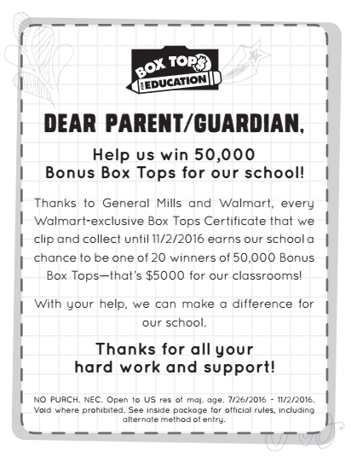

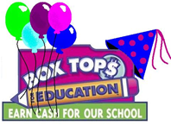

SCA other collections
1 | LINK STORE CARDS – RETURN FUNDRAISING FORM TO OUR SCHOOL
2 | 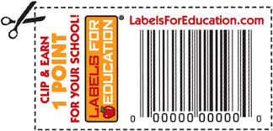  CAMPBELL’S LABELS
3 | INK CARTRIDGES & OLD CELLPHONES
HELP US BY CHECKING EXPIRATION DATES AND CLIPPING ON THE DOTTED LINE! THANKS!

